# **REQUIREMENT ANALYSIS**

| Date | **10 April , 2025** |
| --- | --- |
| Team ID | **SWTID1742907331** |
| Project Title | **MaitriLok : Social Media App** |
| Maximum Marks | **4 Marks** |

## **Customer Journey map**

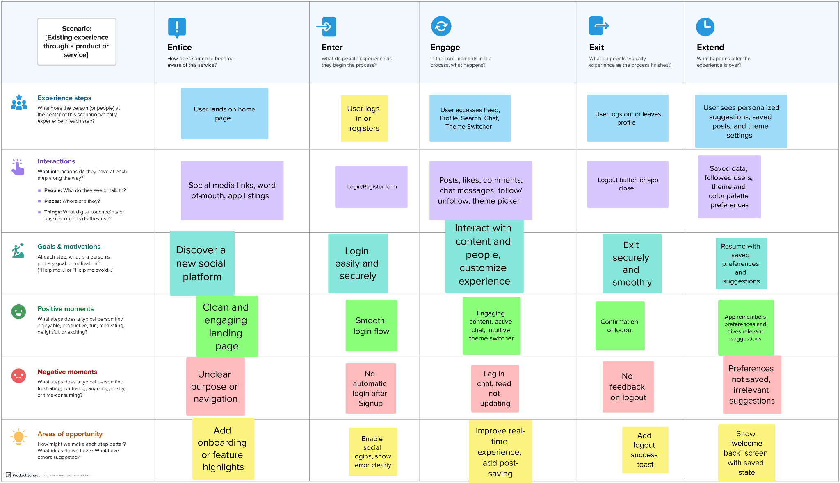

## 

## 

## 

## 

## **Solution Requirement**

| Date | **10 April 2025** |
| --- | --- |
| Team ID | **SWTID1742907331** |
| Project Name | **MaitriLok : Social Media App** |
| Maximum Marks | **4 Marks** |

**Functional Requirements:**

Following are the functional requirements of the proposed solution.

| **FR No.** | **Functional Requirement(Epic)** | **Sub Requirement (Story / Sub-Task)** | **Related Files/Components** |
| --- | --- | --- | --- |
| FR-1 | User Registration | Registration through Form  Login/logout functionality | SignUp.jsx , Login.jsx , authRoutes.js  Logout.jsx, authMiddleware.js |
| FR-2 | User Profile Management | Profile Creation and editing | UserProfile.jsx, EditProfile.jsx, User.js |
| FR-3 | Content Creation and sharing | Create, edit and delete posts | CreatePost.jsx, Post.jsx, postRoutes.js |
| FR-4 | Real time features | Live Chat and messaging system | ChatList.jsx, chatRoutes. js, Chats.js |
| FR-5 | Search and user Posts | Search for Users, Posts | SearchBar.jsx, userRoutes. js, postRoutes. js |
| FR-6 | User panel | User account management | UserProfile.jsx, userController.js |

**Non-functional Requirements:**

Following are the non-functional requirements of the proposed solution.

| **FR No.** | **Non-Functional Requirement** | **Description** | **Implement Reference** |
| --- | --- | --- | --- |
| NFR-1 | **Usability** | For anyone who wants to connect to social media | Simple UI in Feed.jsx,Home.jsx |
| NFR-2 | **Security** | Secure API endpoints | authMiddleware.js,JWT usage |
| NFR-3 | **Reliability** | Regular Backups | Firebase integration for image storage |
| NFR-4 | **Performance** | Fast Page loads | Loading.jsx,Tailwind for fast rendering |
| NFR-6 | **Scalability** | Horizontal Scaling using cloud services | Firebase+Vercel/Render deployment |

## **3.3 Data Flow Diagram**



## 

## **3.4 Technology Stack (Architecture & Stack)**

| Date | **10 April 2025** |
| --- | --- |
| Team ID | **SWTID1742907331** |
| Project Name | **MaitriLok : Social Media App** |
| Maximum Marks | **4 Marks** |



We used the MERN Stack — MongoDB, Express.js, React.js, and Node.js — for full-stack development. For styling, we used Tailwind CSS, and to handle authentication and security, we implemented JWT and bcryptjs. Firebase Storage was used for image uploads and storing media URLs.

| **S.no** | **Components** | **Description** | **Technology** |
| --- | --- | --- | --- |
| **1** | User Interface | Web UI | HTML , TailwindCss , React |
| **2** | Application Logic-1 | Handles user auth, posts, profile logic | Node.js, Express.js |
| **3** | Application Logic-2 | Media upload and URL handling | Firebase Storage SDK |
| **4** | Application Logic-3 | Authentication & Authorization | JWT, bcryptjs |
| **5** | Database | Stores user data, posts, comments | MongoDB |
| **6** | Cloud Database | Hosted NoSQL database | MongoDB Atlas |

# 